INDEX
SR.NO | DATE | TOPIC | SIGNATURE
1. | 22-6-10 | Write a program to create a form to enter bio-data of student. Use various components such as JLabel, JButton, JTextField, JTextArea, JComboBox, JTable, JScrollPane, JOptionButton, and JCheckBox. Use GridBagLayout and GridBagConstraints to lay the components.
2. | 29-6-10 | Construct a simple calculator using the grid bag layout with minimum functionality.
3. | 6-7-10 | Write a java code to accept the query from user at command line argument. Then process this query and using ResultSet and ResultSetMetaData class. Display the result on the screen with proper title of the fields and the fields separator should be ‘|’ (pipe) symbol.
4. | 13-7-10 | Write two servlets in which one servlet will display a form in which data entry can be done for the field’s dept-no, dept-name and location. In the same form place a button called as submit and on click of that button this record should be posted to the table called as DEPT in the database. This inserting of record should be done in another servlet. The second servlet should also display all the previous record entered in the database.
5. | 27-7-10 | Write a program to create a thread use the thread methods:-
6. | 3-8-10 | Define a class that displays information about a file URL like its type, encoding, length, dates of creation, last modification and expiry. Additionally the class should display the request method, response message and the response code for a Web URL.
7. | 10-8-10 | Write a simple server that reports the current time (in textual form) to any client that connects. This server should simply output the current time and close the connection, without reading anything from the client. You need to choose a port number that your service listens on.
8. | 17-8-10 | Create RMI application which calculates the square root of a number using a remote method.
9. | 7-9-10 | A simple client/server application using RMI.The request specifies two numbers. The server adds these together and returns the sum.
10. | 14-9-10 | Write a servlet program which will display current time of server in the client.
11. | 28-9-10 | Write a servlet that accept name of an employee ,basic salary from a html file and display total salary among with the basic.Write a code for html file hra tad a and total salary are calculated as follows:-  Hra=20% of basic  Ta=50% of basic  Da =10% of basic  Total salary = basic +hra+ta+da
12. | 5-10-10 | Write a jsp page to display the current time and date.
13. | 12-10-10 | Write a jsp page that include a simple static file with the help of JSP file.
14. | 19-10-10 | Create a java bean that gives information about the current time. The bean has getter properties for time, hour, minute, and second. Write a JSP page that uses the bean and display all the information.
15. | 7-12-10 | Develop “converter” stateless session bean. Write Enterprise application for converting Japenese yen currency to Euro dollars currency converter consists of an enterprise bean, which performs the calculations and two types of clients:an application client and a web client.
16. | 14-10-10 | Cart Bean : A stateful session bean that is accessed by a remote client.
17. | 21-10-10 | Program to calculate Web Service JSP Client
18. | 11-1-11 | Program to reference calculator WS Application

SWINGS

Practical No:-1

- Write a program to create a form to enter bio-data of student. Use various components such as JLabel, JButton, JTextField, JTextArea, JComboBox, JTable, JScrollPane, JOptionButton, and JCheckBox. Use GridBagLayout and GridBagConstraints to lay the components.

import javax.swing.*;
import java.awt.*;
import java.awt.event.*;
public class BioData extends JFrame
{
int i;
int x=1970;
JLabel lblm,lblName,lblAddress,lblTel,lblGender,lblHobbies,lblEQ,lblLang,lblDate;
JTextField txtName,txtTel;
JTextArea txtAddress;
JCheckBox c1,c2,c3;
JRadioButton r1,r2;
JTable t1;
JList l1;
JButton cmdOk,cmdCancel;
JComboBox date,month,year;
int[] year1;
GridBagLayout gb1=new GridBagLayout();
GridBagConstraints gbc=new GridBagConstraints();
final String[] colHeads={"Year","Percenatage","Class"};
final Object[][] data={
{"2000","87%","S.S.C"},
{"2002","82%","H.S.C"},
{"2003","78%","F.Y.Bsc"},
{"2004","82%","S.Y.Bsc"}
};
String[] listData={"English","Hindi","Marathi"};
String[] mon={"Jan","Feb","March","Apr","May","June","July","Aug","Sep","Oct","Nov","Dec"};
String[] dat={"1","2","3","4","5","6","7","8","9","10","11","12","13","14","15","16","17","18","19 ","20","21","22","23","24","25","26","27","28","29","30","31"};
public BioData()
{
Container con=getContentPane();
con.setLayout(gb1);
lblm=new JLabel();
lblName=new JLabel("Name");
lblAddress=new JLabel("Address");
lblTel=new JLabel("Tel No");
lblGender=new JLabel("Gender");
lblHobbies=new JLabel("Hobbies");
lblEQ=new JLabel("Educational Qualification");
lblLang=new JLabel("Language Known");
lblDate=new JLabel("DOB");
date=new JComboBox(dat);
month=new JComboBox(mon);
year=new JComboBox();
for(i=1970;i<=2010;i++)
{
String str=Integer.toString(i);
year.addItem((Object)str);
}
txtName=new JTextField();
txtTel=new JTextField();
txtAddress=new JTextArea();
int v1=ScrollPaneConstants.VERTICAL_SCROLLBAR_ALWAYS;
int h1=ScrollPaneConstants.HORIZONTAL_SCROLLBAR_ALWAYS;
JScrollPane s1=new JScrollPane(txtAddress,v1,h1);
cmdOk=new JButton("OK");
ButtonListener1 b1=new ButtonListener1(this);
cmdOk.addActionListener(b1);
cmdCancel=new JButton("Cancel");
c1=new JCheckBox("Reading");
c2=new JCheckBox("Music");
c3=new JCheckBox("Movies");
ButtonGroup b=new ButtonGroup();
r1=new JRadioButton("Male");
r2=new JRadioButton("Female");
b.add(r1);
b.add(r2);
t1=new JTable(data,colHeads);
int v=ScrollPaneConstants.VERTICAL_SCROLLBAR_AS_NEEDED;
int h=ScrollPaneConstants.HORIZONTAL_SCROLLBAR_AS_NEEDED;
JScrollPane s=new JScrollPane(t1,v,h);
l1=new JList(listData);
l1.setSelectionMode(ListSelectionModel.MULTIPLE_INTERVAL_SELECTION);
gbc.insets=new Insets(10,10,10,10);
gbc.weightx=1.0;
gbc.fill=GridBagConstraints.HORIZONTAL;
gbc.gridx=0;
gbc.gridy=0;
con.add(lblName,gbc);
gbc.gridx=1;
gbc.gridy=0;
con.add(txtName,gbc);
gbc.gridx=0;
gbc.gridy=1;
gbc.gridheight=2;
con.add(lblAddress,gbc);
gbc.gridx=1;
gbc.gridy=1;
gbc.gridheight=2;
gbc.weighty=1.0;
gbc.fill=GridBagConstraints.BOTH;
con.add(s1,gbc);
gbc.gridx=0;
gbc.gridy=3;
gbc.gridheight=1;
gbc.weighty=0.0;
con.add(lblTel,gbc);
gbc.gridx=1;
gbc.gridy=3;
con.add(txtTel,gbc);
gbc.gridx=0;
gbc.gridy=4;
con.add(lblGender,gbc);
gbc.gridx=1;
gbc.gridy=4;
con.add(r1,gbc);
gbc.gridx=2;
gbc.gridy=4;
con.add(r2,gbc);
gbc.gridx=0;
gbc.gridy=5;
con.add(lblDate,gbc);
gbc.gridx=1;
gbc.gridy=5;
con.add(date,gbc);
gbc.gridx=2;
gbc.gridy=5;
con.add(month,gbc);
gbc.gridx=3;
gbc.gridy=5;
con.add(year,gbc);
gbc.gridx=0;
gbc.gridy=6;
con.add(lblHobbies,gbc);
gbc.gridx=1;
gbc.gridy=6;
con.add(c1,gbc);
gbc.gridx=2;
gbc.gridy=6;
con.add(c2,gbc);
gbc.gridx=3;
gbc.gridy=6;
con.add(c3,gbc);
gbc.gridx=0;
gbc.gridy=7;
con.add(lblEQ,gbc);
gbc.gridx=1;
gbc.gridy=7;
gbc.weighty=1.0;
gbc.gridwidth=gbc.REMAINDER;
con.add(s,gbc);
gbc.gridx=0;
gbc.gridy=8;
gbc.weighty=0.0;
con.add(lblLang,gbc);
gbc.gridx=1;
gbc.gridy=8;
gbc.gridwidth=gbc.REMAINDER;
con.add(l1,gbc);
gbc.gridx=1;
gbc.gridy=9;
gbc.gridwidth=1;
con.add(cmdOk,gbc);
gbc.gridx=2;
gbc.gridy=9;
con.add(cmdCancel,gbc);
gbc.gridx=0;
gbc.gridy=10;
con.add(lblm,gbc);
}
public static void main(String args[])
{
BioData b=new BioData();
b.setVisible(true);
b.setSize(500,500);
b.addWindowListener(new WindowAdapter()
{
public void windowClosing(WindowEvent e)
{
System.exit(0);
}
});
}
}
class ButtonListener1 implements ActionListener
{
BioData bd;
public ButtonListener1(BioData bd)
{
this.bd=bd;
}
public void actionPerformed(ActionEvent e)
{
String a,b,c;
a=bd.txtName.getText();
b=bd.txtTel.getText();
c=bd.txtAddress.getText();
if(a.equals("") || b.equals("") || c.equals(""))
{
JOptionPane.showMessageDialog(bd, "Please enter all the values", "Alert", JOptionPane.ERROR_MESSAGE);
}
if((bd.r1.isSelected()==false) && (bd.r2.isSelected()==false))
{
JOptionPane.showMessageDialog(bd, "Please select the gender", "Alert", JOptionPane.ERROR_MESSAGE);
}
if((bd.c1.isSelected()==false && bd.c2.isSelected()==false && bd.c3.isSelected()==false))
{
JOptionPane.showMessageDialog(bd, "Please select the hobies", "Alert", JOptionPane.ERROR_MESSAGE);
}
}
}

OUTPUT :-

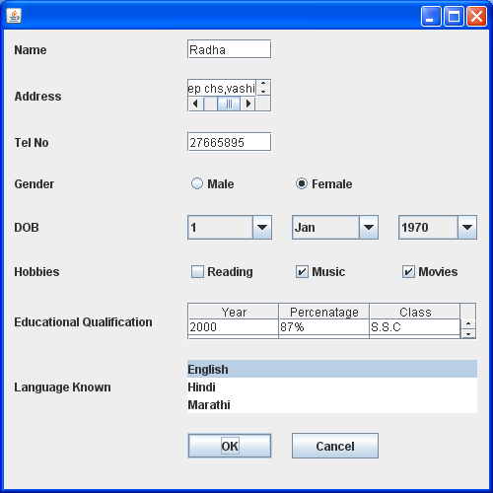
SWINGS
Practical No:-2

- Construct a simple calculator using the grid bag layout with minimum functionality:-

import java.awt.*;
import javax.swing.*;
public class CalciSwing extends JPanel
{
GridBagConstraints gbl = new GridBagConstraints();
JLabel calci = new JLabel("3.1415");
CalciSwing()
{
setLayout(new GridBagLayout());
gbl.weightx=1.0;
gbl.weighty=1.0;
gbl.fill=GridBagConstraints.BOTH;
gbl.gridx=0;
gbl.gridy=0;
add(calci,gbl);
JPanel jp1=new JPanel();
jp1.setLayout(new GridLayout());
gbl.gridx=0;
gbl.gridy=1;
add(jp1,gbl);
gbl.gridx=0;
gbl.gridy=0;
jp1.add(new JButton("C"),gbl);
gbl.gridx=1;
gbl.gridy=0;
jp1.add(new JButton("%"), gbl);
gbl.gridx=2;
gbl.gridy=0;
jp1.add(new JButton("+"),gbl);
JPanel jp2=new JPanel();
jp2.setLayout(new GridLayout());
gbl.gridx=0;
gbl.gridy=2;
add(jp2,gbl);
gbl.gridx=0;
gbl.gridy=0;
jp2.add(new JButton("7"),gbl);
gbl.gridx=1;
gbl.gridy=0;
jp2.add(new JButton("8"),gbl);
gbl.gridx=2;
gbl.gridy=0;
jp2.add(new JButton("9"),gbl);
gbl.gridx=3;
gbl.gridy=0;
jp2.add(new JButton("-"),gbl);
JPanel jp3=new JPanel();
jp3.setLayout(new GridLayout());
gbl.gridx=0;
gbl.gridy=3;
add(jp3,gbl);
gbl.gridx=0;
gbl.gridy=0;
jp3.add(new JButton("4"),gbl);
gbl.gridx=1;
gbl.gridy=0;
jp3.add(new JButton("5"),gbl);
gbl.gridx=2;
gbl.gridy=0;
jp3.add(new JButton("6"),gbl);
gbl.gridx=3;
gbl.gridy=0;
jp3.add(new JButton("*"),gbl);
JPanel jp4=new JPanel();
jp4.setLayout(new GridLayout());
gbl.gridx=0;
gbl.gridy=4;
add(jp4,gbl);
gbl.gridx=0;
gbl.gridy=0;
jp4.add(new JButton("1"),gbl);
gbl.gridx=1;
gbl.gridy=0;
jp4.add(new JButton("2"),gbl);
gbl.gridx=2;
gbl.gridy=0;
jp4.add(new JButton("3"),gbl);
gbl.gridx=3;
gbl.gridy=0;
jp4.add(new JButton("/"),gbl);
JPanel jp5=new JPanel();
jp5.setLayout(new GridLayout());
gbl.gridx=0;
gbl.gridy=5;
add(jp5,gbl);
gbl.gridx=0;
gbl.gridy=0;
jp5.add(new JButton("0"),gbl);
gbl.gridx=1;
gbl.gridy=0;
jp5.add(new JButton("."),gbl);
gbl.gridx=2;
gbl.gridy=0;
jp5.add(new JButton("="),gbl);
}
public static void main(String args[])
{
JFrame frm=new JFrame("Calculator");
frm.setContentPane(new CalciSwing());
frm.setSize(300,350);
frm.setLocation(350,350);
frm.setVisible(true);
}
}

OUTPUT:-

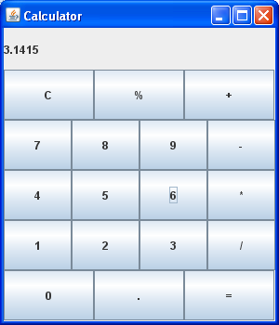

JDBC
Practical No:-3

- Write a java code to accept the query from user at command line argument. Then process this query and using ResultSet and ResultSetMetaData class. Display the result on the screen with proper title of the fields and the fields separator should be ‘|’ (pipe) symbol.

package jdbcdsn;
import java.sql.*;
public class JdbcQuery {
public static void main(String args[])
{
if (args.length != 1)
{
System.out.println("usage : java StatementApp sql");
System.exit(0);
}
try
{
Class.forName("sun.jdbc.odbc.JdbcOdbcDriver");
Connection con=DriverManager.getConnection("jdbc:odbc:demo");
Statement statement = con.createStatement();
String sql = args[0];
System.out.println(sql);
boolean hasresults = statement.execute(sql);
if (hasresults)
{
ResultSet result = statement.getResultSet();
if(result != null)
displayresults(result);
}
con.close();
}
catch(Exception ex)
{
System.out.println(ex);
System.exit(0);
}
}
static void displayresults(ResultSet r) throws SQLException
{
ResultSetMetaData rmeta = r.getMetaData();
int numcolumns = rmeta.getColumnCount();
for(int i=1 ;i <= numcolumns; ++i)
{
if(i < numcolumns)
System.out.print(rmeta.getColumnName(i) + " | ");
else
System.out.println(rmeta.getColumnName(i));
}
while(r.next())
{
for(int i=1 ;i <= numcolumns; ++i)
{
if(i < numcolumns)
System.out.print(r.getString(i) + " | ");
else
System.out.println(r.getString(i).trim());
}
}
}
}

OUTPUT:-

select * from MssSql.dbo.DEPT
deptId | deptName | deptLoc
1 | ABC | VASHI
2 | PQR | THANE
3 | XYZ | NERUL

BUILD SUCCESSFUL (total time: 2 second)

JDBC
Practical No:-4

- Write two servlets in which one servlet will display a form in which data entry can be done for the field’s dept-no, dept-name and location. In the same form place a button called as submit and on click of that button this record should be posted to the table called as DEPT in the database. This inserting of record should be done in another servlet. The second servlet should also display all the previous record entered in the database.

import java.io.IOException;
import java.io.PrintWriter;
import javax.servlet.ServletException;
import javax.servlet.annotation.WebServlet;
import javax.servlet.http.HttpServlet;
import javax.servlet.http.HttpServletRequest;
import javax.servlet.http.HttpServletResponse;
import java.sql.*;
@WebServlet(name="DeptData", urlPatterns={"/DeptData"})
public class DeptData extends HttpServlet {
@Override
public void doGet(HttpServletRequest req,HttpServletResponse res) throws ServletException, IOException
{
res.setContentType("text/html");
PrintWriter out=res.getWriter();
try{
Class.forName("sun.jdbc.odbc.JdbcOdbcDriver");
Connection con=DriverManager.getConnection("jdbc:odbc:demo");
String sql="INSERT INTO MssSql.dbo.DEPT VALUES(?,?,?)";
PreparedStatement ps=con.prepareStatement(sql);
ps.setInt(1,Integer.parseInt(req.getParameter("deptId")));
ps.setString(2,req.getParameter("deptName"));
ps.setString(3,req.getParameter("deptLoc"));
ps.executeUpdate();
Statement st=con.createStatement();
ResultSet rs=st.executeQuery("SELECT * FROM MssSql.dbo.DEPT");
out.print("<html><title>Department Data</title><body>");
out.print("<table border=1>");
out.print("<tr><th>Department No.</th><th>Department Name</th><th>Department Location</th></tr>");
while(rs.next())
{
out.print("<tr><td align=center>"+rs.getInt(1)+"</td>");
out.print("<td align=center>"+rs.getString(2)+"</td>");
out.print("<td align=center>"+rs.getString(3)+"</td></tr>");
}
out.print("</table>");
out.print("<br><br><a href=DeptEntryForm>Add More</a>");
out.print("</body></html>");
out.close();
}catch(Exception e){}
}
@Override
public void doPost(HttpServletRequest req,HttpServletResponse res) throws ServletException, IOException
{
doGet(req,res);
}
}

DeptEntryForm:-

import java.io.IOException;
import java.io.PrintWriter;
import java.util.logging.Level;
import java.util.logging.Logger;
import javax.servlet.ServletException;
import javax.servlet.annotation.WebServlet;
import javax.servlet.http.HttpServlet;
import javax.servlet.http.HttpServletRequest;
import javax.servlet.http.HttpServletResponse;
@WebServlet(name="DeptEntryForm", urlPatterns={"/DeptEntryForm"})
public class DeptEntryForm extends HttpServlet
{
protected void processRequest(HttpServletRequest request, HttpServletResponse response)
throws ServletException, IOException {
}
@Override
protected void doGet(HttpServletRequest request, HttpServletResponse response)
throws ServletException, IOException {
response.setContentType("text/html;charset=UTF-8");
PrintWriter out = response.getWriter();
try {
out.print("<html><title>Department Entry Form</title><body>");
out.print("<form method=post action=http://localhost:8080/Radha/DeptData>");
out.print("Department Id: <Input type=text name=deptId>");
out.print("<br>Department Name: <Input type=text name=deptName>");
out.print("<br>Department Location: <Input type=text name=deptLoc>");
out.print("<br><Input type=submit value='Add Department'>");
out.print("<input type=reset value=Reset>");
out.print("</body></html>");
out.close();
} catch (Exception ex)
} finally {
out.close();
}
}
@Override
protected void doPost(HttpServletRequest request, HttpServletResponse response)
throws ServletException, IOException {
//processRequest(request, response);
doGet(request, response);
}
@Override
public String getServletInfo() {
return "Short description";
}
}

OUTPUT:-

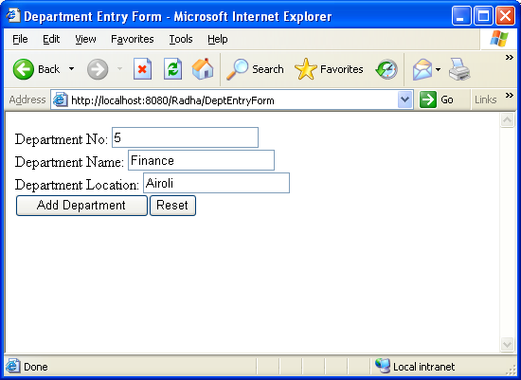

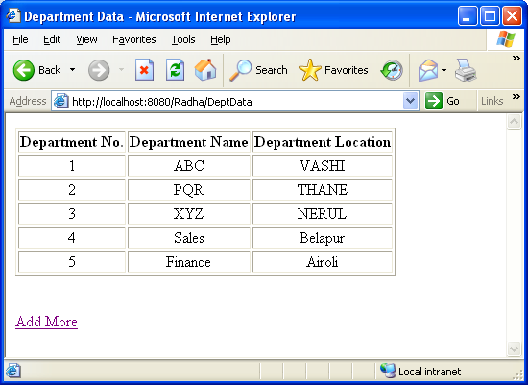

THREADING
Practical No:-5
- Write a program to create a thread use the thread methods:-

import java.io.*;
import java.net.*;
class thread1 extends Thread
{
public void run()
{
try
{
for(int i=0;i<5;i++)
{
System.out.println("I's value= " + i);
}
sleep(1000);
}
catch(Exception e) { }
}
}
class thread2 extends Thread
{
public void run()
{
try
{
for(int j=6;j<10;j++)
{
System.out.println("J's value= "+j);
}
yield();
}
catch(Exception e){ }
}
}
class thread3 extends Thread
{
public void run()
{
try
{
for(int k=11;k<15;k++)
{
System.out.println("K's value= "+k);
}
notify();
}
catch(Exception e) { }
}
}
class thread4 extends Thread
{
public void run()
{
try
{
for(int l=20;l<25;l++)
{
System.out.println("L's value= "+l);
}
stop();
}
catch(Exception e){ }
}
}
class thread5 extends Thread
{
public void run()
{
try
{
for(int m=30;m<35;m++)
{
System.out.println("M's value= "+m);
}
wait();
}
catch(Exception e) { }
}
}
public class cmthread
{
public static void main(String args[])
{
thread1 t1=new thread1();
t1.start();
System.out.println("Thread 1 started");
thread2 t2=new thread2();
t2.start();
System.out.println("Thread 2 started");
thread3 t3=new thread3();
t3.start();
System.out.println("Thread 3 started");
thread4 t4=new thread4();
t4.start();
System.out.println("Thread 4 started");
thread5 t5=new thread5();
t5.start();
System.out.println("Thread 5 started");
}
}

OUTPUT:-

Thread 1 started
I's value= 0
I's value= 1
I's value= 2
I's value= 3
Thread 2 started
J's value= 6
J's value= 7
J's value= 8
J's value= 9
I's value= 4
Thread 3 started
K's value= 11
K's value= 12
Thread 4 started
L's value= 20
L's value= 21
L's value= 22
L's value= 23
L's value= 24
K's value= 13
K's value= 14
Thread 5 started
M's value= 30
M's value= 31
M's value= 32
M's value= 33
M's value= 34
BUILD SUCCESSFUL (total time: 1 second)

NETWORKING
Practical No:-6
- Define a class that displays information about a file URL like its type, encoding, length, dates of creation, last modification and expiry. Additionally the class should display the request method, response message and the response code for a Web URL.

import java.net.*;
import java.util.*;
class URLDemo
{
long d;
public static void main(String args[])throws Exception
{
URL u=new URL("http://localhost:8080/Radha/ShowTime.jsp");
URLConnection uc=u.openConnection();
HttpURLConnection huc=(HttpURLConnection)uc;
Date d=new Date(uc.getDate());
System.out.println("File Name ="+u.getFile());
System.out.println("Host Name="+u.getHost());
System.out.println("Path Name="+u.getPath());
System.out.println("Port Name="+u.getPort());
System.out.println("Protocol Name="+u.getProtocol());
System.out.println("Reference Name="+u.getRef());
System.out.println("User Info="+u.getUserInfo());
System.out.println("Content Name="+u.getContent());
System.out.println("Authority Name="+u.getAuthority());
System.out.println("Content Type="+uc.getContentType());
System.out.println("Length="+uc.getContentLength());
System.out.println("Expiration Date= "+uc.getExpiration());
System.out.println("Encoding Type= "+uc.getContentEncoding());
System.out.println("Last Modified Date= "+uc.getLastModified());
System.out.println("Date="+d.toString());
System.out.println("Request Method= "+huc.getRequestMethod());
System.out.println("Response Message= "+huc.getResponseMessage());
System.out.println("Response Code= "+huc.getResponseCode());
}
}

OUTPUT:-

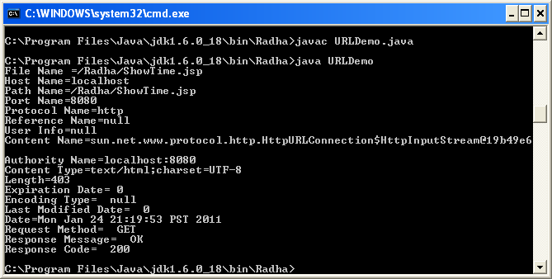

NETWORKING
Practical No:-7
- Write a simple server that reports the current time (in textual form) to any client that connects. This server should simply output the current time and close the connection, without reading anything from the client. You need to choose a port number that your service listens on.

TimeServer

import java.net.*;
import java.io.*;
import java.util.*;
class TimeServer
{
public static void main(String args[])throws Exception
{
ServerSocket s=new ServerSocket(1234);
Socket c=s.accept();
Calendar calendar = new GregorianCalendar();
PrintWriter out=new PrintWriter(c.getOutputStream());
out.println(new Date());
out.println("Time :");
out.print(calendar.get(Calendar.HOUR)+"HRS."+calendar.get
(Calendar.MINUTE)+"MIN."+calendar.get(Calendar.SECOND)+"SEC");
out.flush();
s.close();
c.close();
}
}

TimeClient:-

import java.net.*;
import java.io.*;
import java.util.*;
class TimeClient
{
public static void main(String args[])throws Exception
{
Socket c=new Socket(InetAddress.getLocalHost(),1234);
BufferedReader br=new BufferedReader(new InputStreamReader(c.getInputStream()));
String userInput;
while((userInput=br.readLine())!=null)
{
System.out.println(userInput);
}
c.close();
}
}

OUTPUT:-

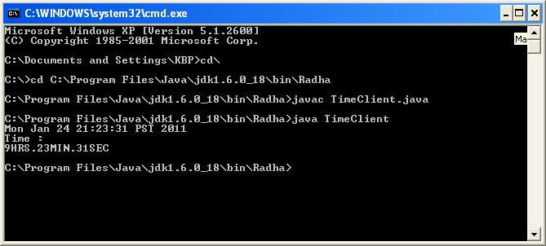

RMI PRACTICAL
Practical No:-8
- Create RMI application which calculates the square root of a number using a remote method.

RMICLIENT :-

import java.rmi.*;
import java.rmi.registry.*;
public class RMIClient
{
public static void main(String args[])
{
try
{
MethodImpl mthdimp=(MethodImpl)Naming.lookup("rmi://localhost/call");
double dbl = mthdimp.getSqrt(100);
System.out.println("SQRT: "+dbl);
}
catch(Exception ex)
{
System.out.println("Erros in Client----- "+ex.toString());
ex.printStackTrace();
}
}
}

RMISERVER :-

import java.rmi.*;
import java.rmi.registry.*;
import java.rmi.server.*;
public class RMIServer extends UnicastRemoteObject implements MethodImpl
{
public RMIServer()throws RemoteException
{
System.out.println("The server is instantitiated");
}
public double getSqrt(double dbl)
{
return Math.sqrt(dbl);
}
public static void main(String args[])
{
try
{
RMIServer server=new RMIServer();
Naming.rebind("call",server);
}
catch(Exception e)
{
System.out.println("Error------" +e.toString());
e.printStackTrace();
}
}
}

METHODIMPL :-

import java.rmi.*;
public interface MethodImpl extends Remote
{
double getSqrt(double dbl)throws RemoteException;
}

OUTPUT:-

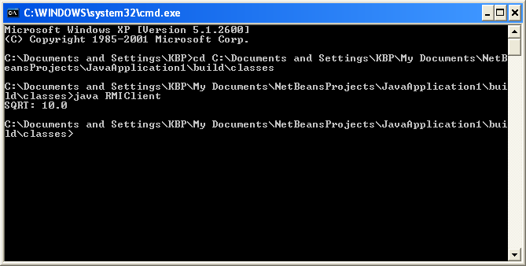

RMI PRACTICAL
Practical No:-9

- A simple client/server application using RMI.The request specifies two numbers. The server adds these together and returns the sum.

ADDCLIENT:-

import java.rmi.*;
public class AddClient
{
public static void main(String args[])
{
try
{
String addServerURL = "rmi://localhost/AddServer";
AddServerIntf addserverIntf = (AddServerIntf) Naming.lookup(addServerURL);
System.out.println("The First number is : "+args[0]);
double d1 = Double.valueOf(args[0]).doubleValue();
System.out.println("The Second number is : "+args[1]);
double d2 = Double.valueOf(args[1]).doubleValue();
System.out.println("The Sum is : "+addserverIntf.add(d1, d2));
}
catch(Exception e){
System.out.println("Exception----"+e);
}
}
}

ADDSERVER:-
import java.net.*;
import java.rmi.*;
import java.rmi.server.UnicastRemoteObject;
public class AddServer //extends UnicastRemoteObject implements AddServerIntf
{
public static void main(String args[]){
try
{
AddServerImpl addserver=new AddServerImpl();
Naming.rebind("AddServer", addserver);
}
catch(Exception e)
{
System.out.println("Excaption: "+e);
}
}
}

ADDSERVERIMPL:-
import java.rmi.*;
import java.rmi.server.*;
public class AddServerImpl extends UnicastRemoteObject implements AddServerIntf
{
public AddServerImpl() throws RemoteException { }
public double add(double d1, double d2) throws RemoteException
{
return d1 + d2;
}
}

ADDSERVERINTF:-
import java.rmi.*;
public interface AddServerIntf extends Remote
{
double add(double d1,double d2)throws RemoteException;
}

OUTPUT:-

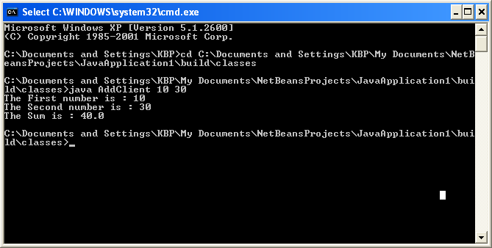

SERVLETS
Practical No:-10

- Write a servlet program which will display current time of server in the client.

import java.io.IOException;
import java.io.PrintWriter;
import javax.servlet.ServletException;
import javax.servlet.annotation.WebServlet;
import javax.servlet.http.HttpServlet;
import javax.servlet.http.HttpServletRequest;
import javax.servlet.http.HttpServletResponse;
@WebServlet(name="TimeServlet", urlPatterns={"/TimeServlet"})
public class TimeServlet extends HttpServlet
{
public void processRequest(HttpServletRequest request, HttpServletResponse response)
throws ServletException, IOException
{
response.setContentType("text/html");
PrintWriter out = response.getWriter();
java.util.Date today = new java.util.Date();
try
{
out.println("<html>");
out.println("<head>");
out.println("<title>Servlet TimeServlet</title>");
out.println("</head>");
out.println("<body>");
out.println("<h1>Servlet TimeServlet at</br> " +today + "</h1>");
out.println("</body>");
out.println("</html>");
}
finally
{
out.close();
}
}
@Override
public void doGet(HttpServletRequest request, HttpServletResponse response)
throws ServletException, IOException
{
processRequest(request, response);
}
}

OUTPUT :-

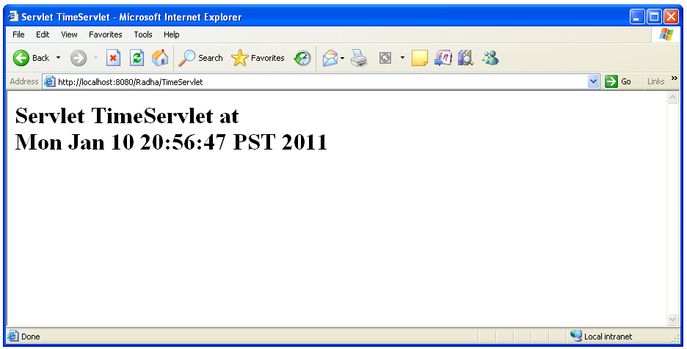

SERVLETS
Practical No:-11

- Write a servlet that accept name of an employee ,basic salary from a html file and display total salary among with the basic.Write a code for html file hra tad a and total salary are calculated as follows:-
Hra=20% of basic
Ta=50% of basic
Da =10% of basic
Total salary = basic +hra+ta+da

import java.io.IOException;
import java.io.PrintWriter;
import javax.servlet.*;
public class EmployeeServlet extends GenericServlet
{
public void service(ServletRequest request, ServletResponse response)
throws ServletException, IOException
{
response.setContentType("text/html;charset=UTF-8");
PrintWriter out = response.getWriter();
String strName=request.getParameter("name");
int intBSalary =(Integer.parseInt(request.getParameter("sal")));
int hra=intBSalary * 20 /100;
System.out.println("hra--"+ hra);
int ta= intBSalary * 15 /100;
System.out.println("ta--"+ ta);
int da=intBSalary * 10/100;
System.out.println("da--"+ da);
int intTotalSal=(intBSalary)+(hra)+(ta)+(da);
System.out.println("intTotalSal--"+intTotalSal);
try {
// /* TODO output your page here
out.println("<html>");
out.println("<head>");
out.println("<title>Servlet EmployeeServlet</title>");
out.println("</head>");
out.println("<body>");
out.println("<h1>");
out.println("Name of Employee : "+strName);
out.println("</h1>");
out.println("<h1>");
out.println("Basic Salary : "+intBSalary);
out.println("</h1>");
out.println("<h1>");
out.println("Total Salary : "+intTotalSal);
out.println("</h1>");
out.println("</body>");
out.println("</html>");
// */
} finally {
out.close();
}
}
}

EMPLOYEE.HTML

<!DOCTYPE HTML PUBLIC "-//W3C//DTD HTML 4.01 Transitional//EN">
<html>
<head>
<title></title>
<meta http-equiv="Content-Type" content="text/html; charset=UTF-8">
</head>
<body>
<form action ="http://localhost:8080/MyThirdServlet/EmployeeServlet" method=get>
<h2>Enter the Employee Name=<input type="text" name="name"></h2>
<h2>Enter the Employee Basic Salary =<input type="text" name="sal"></h2>
<input type="submit" name="submit">
<input type="reset" name="reset">
</form>
</body>
</html>

OUTPUT:-

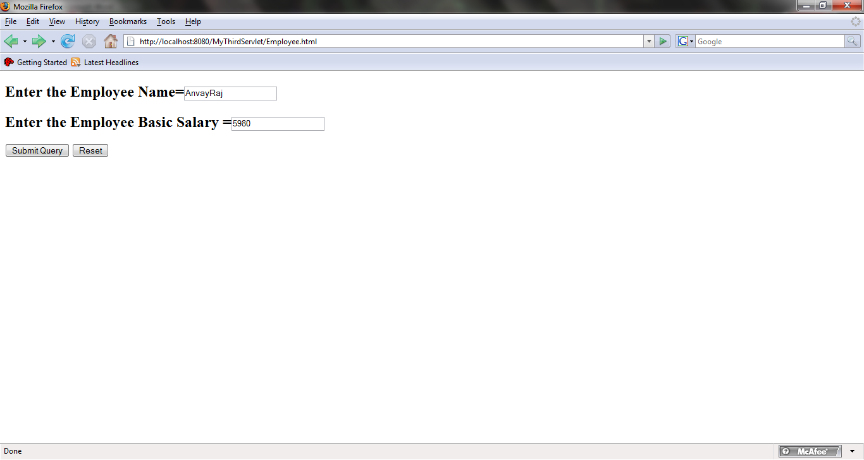

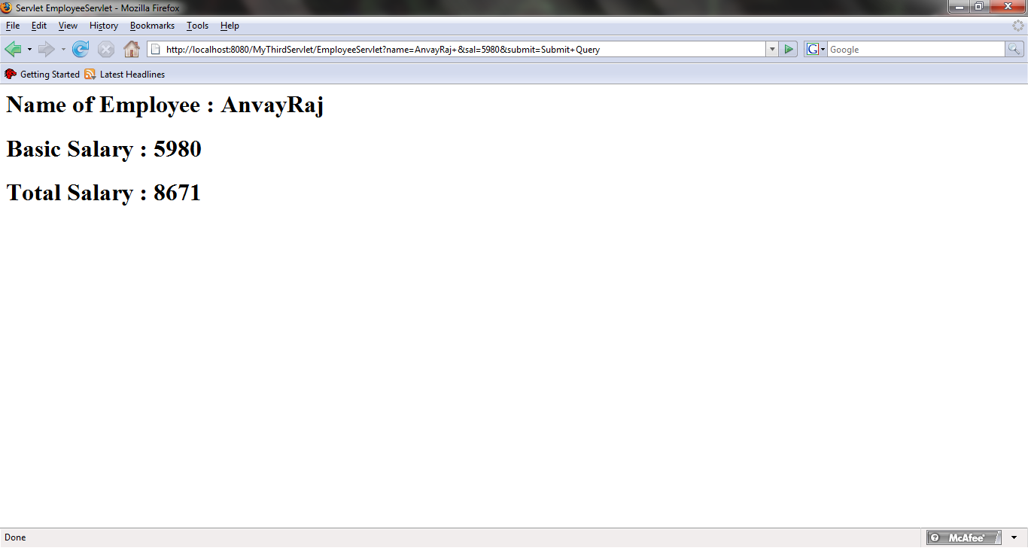

JSP
Practical No:-12

- Write a jsp page to display the current time and date.

<%@page contentType="text/html" pageEncoding="UTF-8"%>
<!DOCTYPE HTML PUBLIC "-//W3C//DTD HTML 4.01 Transitional//EN"
"http://www.w3.org/TR/html4/loose.dtd">
<html>
<head>
<meta http-equiv="Content-Type" content="text/html; charset=UTF-8">
<title>JSP Page</title>
</head>
<body>
<h2>TO DISPLAY CURRENT DATE & TIME</h2>
<h1><center>Current Time:<%=new java.util.Date()%></center></h1>
</body>
</html>

OUTPUT:

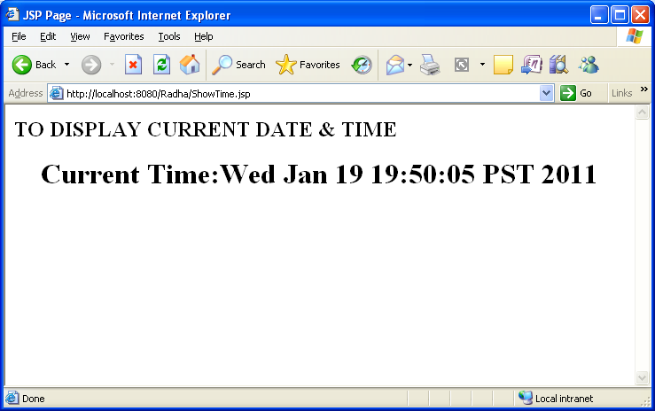

JSP
Practical No:-13
- Write a jsp page that include a simple static file with the help of JSP file.

<%@include file="ShowTime.jsp"%> & a simple JSP page with the help of <jsp:include page="ShowTime.jsp"/> tag.
<%@page contentType="text/html" pageEncoding="UTF-8"%>
<!DOCTYPE HTML PUBLIC "-//W3C//DTD HTML 4.01 Transitional//EN"
"http://www.w3.org/TR/html4/loose.dtd">
<html>
<head>
<meta http-equiv="Content-Type" content="text/html; charset=UTF-8">
<title>JSP Page</title>
</head>
<body bgcolor="blue">
<font color="white">
<center><h3>By using include tag the jsp file show the current Date & Time</h3>
<%@include file="ShowTime.jsp"%>
<h3>by including the jsp include tag:</h3>
<jsp:include page="ShowTime.jsp"/>
</center>
</font>
</body>
</html>

OUTPUT:-

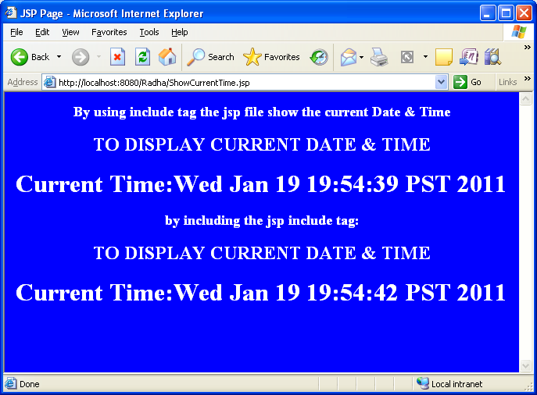

JSP

Practical No:-14

- Create a java bean that gives information about the current time. The bean has getter properties for time, hour, minute, and second. Write a JSP page that uses the bean and display all the information.

<%@page contentType="text/html" pageEncoding="UTF-8"%>
<!DOCTYPE HTML PUBLIC "-//W3C//DTD HTML 4.01 Transitional//EN"
"http://www.w3.org/TR/html4/loose.dtd">
<html>
<head>
<meta http-equiv="Content-Type" content="text/html; charset=UTF-8">
<title>JSP Page</title>
</head>
<body>
<jsp:useBean class="MyDate.CalendarBean" id="clock" />
<pre>
Time:<jsp:getProperty name="clock" property="time" /><br>
Hour:<jsp:getProperty name="clock" property="hour" /><br>
Minute:<jsp:getProperty name="clock" property="minute" /><br>
Second:<jsp:getProperty name="clock" property="second" /><br>
</pre>
</body>
</html>

CALENDARBEAN:-

MyDate.CalendarBean;
package MyDate;
import java.util.Calendar;
import java.util.Date;
public class CalendarBean
{
private Calendar calendar;
private Date time;
private int hour,minute,second;
public CalendarBean()
{
calendar=Calendar.getInstance();
calendar.setTime(new Date());
}
public Date getTime()
{
return calendar.getTime();
}
public int getHour()
{
return calendar.get(Calendar.HOUR_OF_DAY);
}
public int getMinute()
{
return calendar.get(Calendar.MINUTE);
}
public int getSecond()
{
return calendar.get(Calendar.SECOND);
}
}

OUTPUT:-

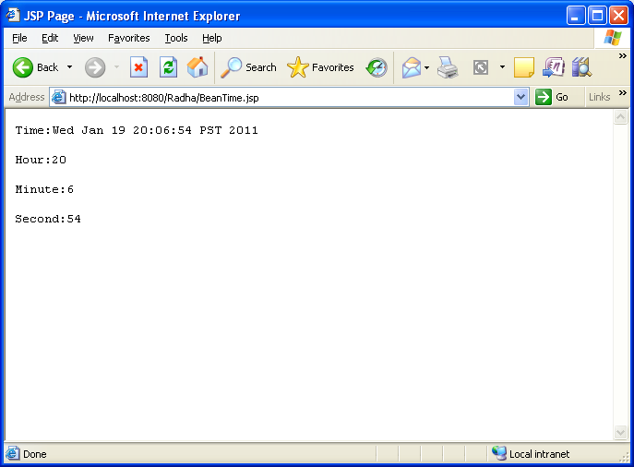

EJB
Practical No:-15
- Develop “converter” stateless session bean. Write Enterprise application for converting Japenese yen currency to Euro dollars currency converter consists of an enterprise bean, which performs the calculations and two types of clients:an application client and a web client.

CONVERTER ejb:-

Converter.java

package converter.ejb;
import java.math.BigDecimal;
import javax.ejb.Remote;
@Remote
public interface Converter {
public BigDecimal dollarToYen(BigDecimal dollars);
public BigDecimal yenToEuro(BigDecimal yen);
}

ConverterBean.java:-

package converter.ejb;
import java.math.BigDecimal;
import javax.ejb.*;
@Stateless
public class ConverterBean implements Converter {
private BigDecimal yenRate = new BigDecimal("115.3100");
private BigDecimal euroRate = new BigDecimal("0.0071");
@Override
public BigDecimal dollarToYen(BigDecimal dollars) {
BigDecimal result = dollars.multiply(yenRate);
return result.setScale(2, BigDecimal.ROUND_UP);
}
@Override
public BigDecimal yenToEuro(BigDecimal yen) {
BigDecimal result = yen.multiply(euroRate);
return result.setScale(2, BigDecimal.ROUND_UP);
}

}

CONVERTER-appClient:-

ConverterClient.java:-

package converter.client;
import java.math.BigDecimal;
import javax.ejb.EJB;
import converter.ejb.Converter;
public class ConverterClient {
@EJB
private static Converter converter;
public ConverterClient(String[] args) {
}
public static void main(String[] args) {
ConverterClient client = new ConverterClient(args);
client.doConversion();
}
public void doConversion() {
try {
BigDecimal param = new BigDecimal("100.00");
BigDecimal yenAmount = converter.dollarToYen(param);
System.out.println("$" + param + " is " + yenAmount
+ " Yen.");
BigDecimal euroAmount = converter.yenToEuro(yenAmount);
System.out.println(yenAmount + " Yen is " + euroAmount
+ " Euro.");
System.exit(0);
} catch (Exception ex) {
System.err.println("Caught an unexpected exception!");
ex.printStackTrace();
}
}
}

CONVERTER-War:-

<%@page contentType="text/html" pageEncoding="UTF-8"%>
<!DOCTYPE HTML PUBLIC "-//W3C//DTD HTML 4.01 Transitional//EN"
"http://www.w3.org/TR/html4/loose.dtd">
<%@ page import="converter.ejb.Converter, java.math.*, javax.naming.*"%>
<%!
private Converter converter = null;
public void jspInit() {
try {
InitialContext ic = new InitialContext();
converter = (Converter)
ic.lookup(Converter.class.getName());
} catch (Exception ex) {
System.out.println("Couldn’t create converter bean."+
ex.getMessage());
}
}
public void jspDestroy() {
converter = null;
}
%>
<html>
<head>
<title>Converter</title>
</head>
<body bgcolor="white">
<h1>Converter</h1>
<hr>
<p>Enter an amount to convert:</p>
<form method="get">
<input type="text" name="amount" size="25">
<br>
<p>
<input type="submit" value="Submit">
<input type="reset" value="Reset">
</form>
<%
String amount = request.getParameter("amount");
if ( amount != null && amount.length() > 0 ) {
BigDecimal d = new BigDecimal(amount);
BigDecimal yenAmount = converter.dollarToYen(d);
%>
<p>
<%= amount %> dollars are <%= yenAmount %> Yen.
<p>
<%
BigDecimal euroAmount =
converter.yenToEuro(yenAmount);
%>
<%= yenAmount %> Yen are <%= euroAmount %> Euro.
<%
}
%>
</body>
</html>

OUTPUT:-

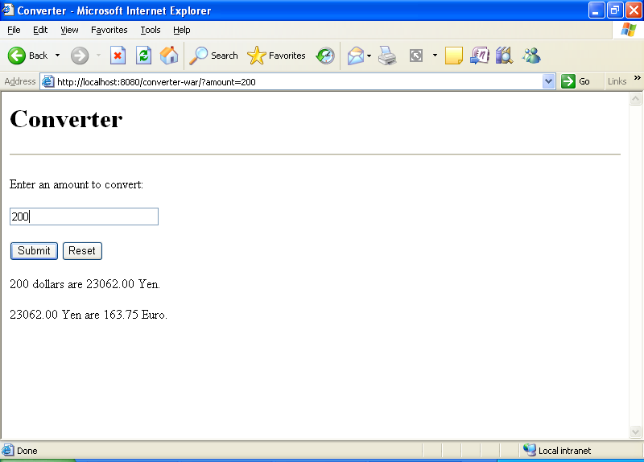

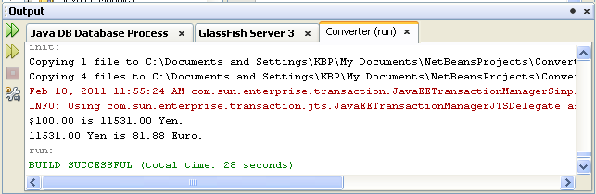

EJB

Practical No:-16

- Cart Bean : A stateful session bean that is accessed by a remote client.

CART-Ejb :-

- Cart-ejb package:-

CartBean interface:-

package cart.ejb;
import cart.util.BookException;
import cart.util.IdVerifier;
import java.util.List;
import javax.ejb.Remove;
import javax.ejb.Stateful;
import java.util.ArrayList;
@Stateful()
public class CartBean implements Cart
{
List<String> contents;
String customerId;
String customerName;
public void initialize(String person)throws BookException
{
if(person==null){
throw new BookException("Null person not allowed.");
}else{
customerName = person;
}
customerId="0";
contents = new ArrayList<String>();
}
public void initialize(String person,String id)throws BookException
{
if(person==null)
{
throw new BookException("Null person not allowed.");
}else{
customerName = person;
}
IdVerifier idChecker = new IdVerifier();
if(idChecker.validate(id)) {
customerId = id;
}
else
{
throw new BookException("Invalid id : " +id);
}
contents = new ArrayList<String>();
}

public void addBooks(String title)
{
contents.add(title);
}

public void removeBook(String title) throws BookException
{
boolean result = contents.remove(title);
if(result==false){
throw new BookException("\""+title+"\"not in cart.");
}
}
public List<String> getContents()
{
return contents;
}
@Remove()
public void remove() {
contents = null;
}
}

Class Cart.java:-

package cart.ejb;
import cart.util.BookException;
import java.util.List;
import javax.ejb.Remote;
@Remote
public interface Cart
{
public void initialize(String person)throws BookException;
public void initialize(String person,String id)throws BookException;
public void addBooks(String title);
public void removeBook(String title)throws BookException;
public List<String> getContents();
public void remove();
}

- Cart util package:-

- BookException.java class:-

package cart.util;

public class BookException extends Exception{
public BookException()
{
}
public BookException(String msg)
{
super(msg);
}
}

- IdVerifier.java class:-
package cart.util;
public class IdVerifier
{
public IdVerifier()
{
}
public boolean validate(String id)
{
boolean result = true;
for(int i=0;i<id.length();i++){
if(Character.isDigit(id.charAt(i))==false){
result = false;
}
}
return result;
}
}

Cart-app-Client:-
cart.client package
CartClient.java class:-
package cart.client;
import cart.util.BookException;
import java.util.List;
import javax.ejb.EJB;
import cart.ejb.Cart;
import java.util.Iterator;
import java.util.List;
public class CartClient {
@EJB
private static Cart cart;
public CartClient(String[] args) {
}
public static void main(String[] args)
{
CartClient client = new CartClient(args);
client.doTest();
}
public void doTest()
{
try
{
cart.initialize("JNL", "123");
cart.addBooks("Compiler Design");
cart.addBooks("Data Structure");
cart.addBooks("Operating System");
cart.addBooks("Networking");
List<String> bookList = cart.getContents();
bookList = cart.getContents();
Iterator<String> iterator = bookList.iterator();
while(iterator.hasNext()){
String title = iterator.next();
System.out.println("Retrieving book title from cart : "+title);
}
System.out.println("Removing\"Gravity's Rainbow\" from cart.");
cart.removeBook("Gravity's Rainbow");
cart.remove();
System.exit(0);
}
catch(BookException ex)
{
System.out.println("Caught a BookException : "+ex.getMessage());
System.exit(1);
}
catch(Exception ex)
{
System.out.println("Caught an unexpected exception !");
ex.printStackTrace();
System.exit(1);
}
}
}

OUTPUT:-
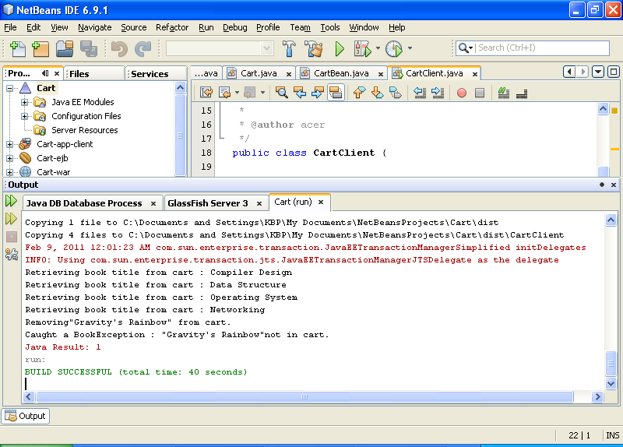

WEB SERVICES
Practical No:-17
- Program to calculate Web Service JSP Client:-

package org.me.calculator;
import javax.jws.WebMethod;
import javax.jws.WebParam;
import javax.jws.WebService;
@WebService()
public class CalculatorWS
{
@WebMethod(operationName = "add")
public int add(@WebParam(name = "i") int i, @WebParam(name = "j") int j)
{
return i + j;
}
}

OUTPUT:

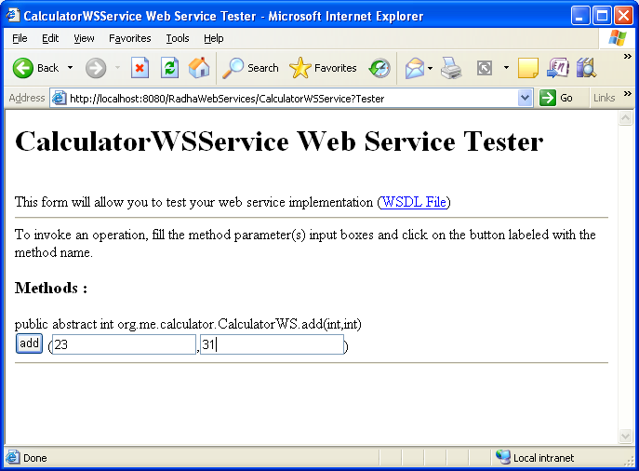

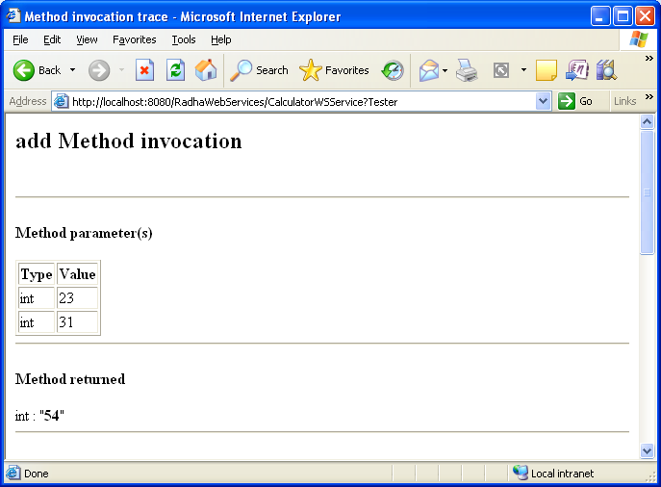

WEB SERVICES
Practical No:-18
- Program to reference calculator WS Application:-

<%@page contentType="text/html" pageEncoding="UTF-8"%>
<!DOCTYPE HTML PUBLIC "-//W3C//DTD HTML 4.01 Transitional//EN"
"http://www.w3.org/TR/html4/loose.dtd">
<html>
<head>
<meta http-equiv="Content-Type" content="text/html; charset=UTF-8">
<title>JSP Page</title>
</head>
<body>
<h1>JSP Page</h1>
<%--start web service invocation--%><hr/>
<%
try{
org.me.calculator.CalculatorWSService service = new org.me.calculator.CalculatorWSService();
org.me.calculator.CalculatorWS port = service.getCalculatorWSPort();
int i=8,j=2;
int result=port.add(i, j);
out.println("Result = "+result);
}
catch(Exception e){
e.printStackTrace();
}
%>
<%--end web service invocation--%><hr/>
</body>
</html>

OUTPUT:-
